Statistics Assignment

Name

Institutional Affiliation
Professor

Date
Statistics Assignment
Question 1 (6 marks)
Evaluate the stock returns of S&P 500 and S&P 500 Environmental & Socially Responsible Index using the descriptive statistics: mean, median, mode and standard deviation and an appropriate graphical presentation of the two return series.
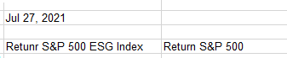

Question 2 (6 marks)

Evaluate whether the returns of the stock returns of S&P 500 and S&P 500 Environmental & Socially Responsible Index are normally distributed. You need to construct histograms to evaluate the return distribution of each return series. Also, you need to use the mean, median, and mode of each return series to evaluate the normality.

Question 3 (13 marks)

- For each return series, generate 20 random samples with a sample size of 50 and 100, respectively, viz. 40 samples for each series, and a total of 80 samples for 2 series. (5 marks)

- Compute the mean for each sample.

- Construct a histogram of the sample means for each series, viz. sampling distribution of the mean.
(b+c = 5 marks)
- Comparing to the histograms in Question 2, which histograms appear to be more normal? What is the underlying theory that explains this phenomenon? (3 marks)

Q1. The returns for the S&P 500 and S&P 500 ESG index are closely related from their mode, mean, median and standard deviation. All these are close together, which means that both indices may have an equal amount of return. The S&P 500 has a mean of 0.000475064, mode of zero, the median is 0.000662896, and the standard deviation is 0.011032122, while the S&P 500 ESG has a mean of 0.000483534, a mode of zero, median of 0.000703687 and a standard deviation of 0.010977417. Looking at these data, we can make a conclusion that the two are closely related. The graph plotted with the two indices also tells us that both bring the same amount of return as below:

Q2. From the analysis of the data, most of the revenue is mostly distributed in the range of 0.01 for both the returns. This shows that the data is not normally distributed as we can see a higher concentration in one point while other points do not have much frequent. The histograms look normal since they can form a bell shape if connected together.

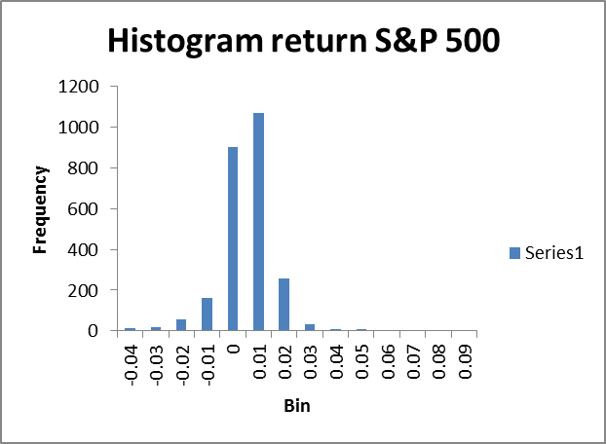

Q3b). When we select a sample of 40 samples randomly data, the mean goes up from 0.000475 and 0.000473 to 0.00324 and 0.00312 for the S&P 500 and S&P 500 ESG, respectively.
Mean Return S&P 500 ESG Index | Mean Return S&P 500
0.00312459 | 0.003243571

Q3c). The results of the 40 samples of the data give a histogram that is well distributed through the data concentration is still at 0.01. The highest frequency of each sample is 0.004 for the return 500 ESG and 0.001 for the return 500 index

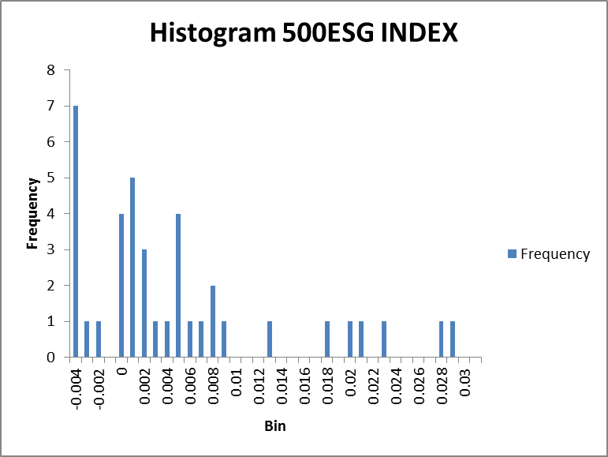

Q3d). The histograms are not normal as bars appear in different lengths at different points and cannot form a bell shape. This is derived from the central limit theorem.

